KEYAZ CONSULTANCY
MIDTERM II EXAMINATION 2023
Age Group (4 – 5 years): MIDDLE CLASS
Learning Area 5: Reading

My name is ______________________________________________
School: _____________________________________________________
- Circle the correct sound for the pictures.
 | l p f
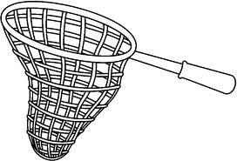 | n o t
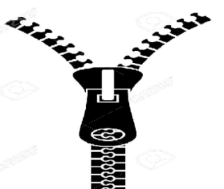 | p i z
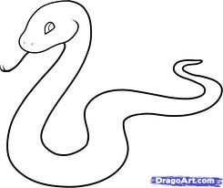 | k s e
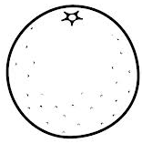 | o r g
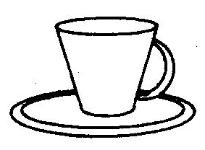 | u c b
- Match the same syllable and write.
ha
ba ha __________
ca ga __________
da fa __________
fa ba __________
ga ca ___________
ha da ___________
- Read and draw.
bed

hen

pen

leg

ten

- Fill in the missing vowels.
a, _______, i ______, u
- Fill in sound ‘o” and read.
b ____ y t ___p
d ____ll p ___t
h ___t b ___x
- Draw pictures for the syllable.
ba ma
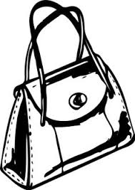

ca

ra

ya
- Copy and write.
J j J j J j J j
________________________________________________________________________________________________________________________________________________________________________________________________________________________________________________________________________________________________
jug jump jim

________________________________________________________________________________________________________________________________________________________________________________________________________________________________________________________________________________________________

Where is the jug?

________________________________________________________________________________________________________________________________________________________________________________________________________________________________________________________________________________________

END

